Project Report

*Start-Up Business-Model- and Platform Development*

Yannick Nann, Peter Grüner, Simon Wild and Isabelle Ribeiro

Supervisor

Prof. Knut Hinkelmann

October 18, 2019

FHNW Modul: Agile Business Analysis

**Master of Science in Business Information Systems**

# Table of Contents

Table of Contents 2

1 Introduction 3

2 Objectives 4

3 Approach 5

3.1 Design Thinking Phase 5

3.2 Sprint Cycles 5

4 Roles & Stakeholders 7

5 Design Thinking Phase 8

5.1 Environment and impact factors of the Start Up 8

5.2 Empathize: Research in the Area 8

5.3 Define: Potential Service Descriptions 8

5.4 Ideate: Sharing Ideas and Prioritize 8

5.5 Definition of Company Name 8

5.6 Choosen MVP Scope 8

6 Backlog (Initiative, Epics, Userstories) 10

7 First Sprint 10

# Introduction

Regarding the Global Innovation Index (2019), Switzerland is once again the most innovative country in the world. Besides this fact, it also has a booming startup scene with plenty of funds available to realize potential business ideas. This results in a great environment for eentrepreneurs with creative ideas to generate value for our society.

One very common concept is the platform business model. Its main purpose is to connect resources instead of owning them. Role models such as Uber, AirBnB or Tinder inspire many people to start their own platform business, but most of them still fail (Yoffie, Gawer, & Cusumano, 2019).

The projects main goal is, to develop a business model, with special focus on the selection of the ideal customer segment and value proposition for such a platform model in an agile way. Therefore, the project is split into several sprints with high involvement of its stakeholders to optimize its customer centricity and convenience for ideal market potential. Besides the project management based on the BABOK Guide (International Institute of Business Analysis, 2015), also the LEAN-Start up idea from Eric Ries (2011) which follows a “fail fast – fail cheap” approach.

# Objectives

Customer Segment and value proposition

# Approach

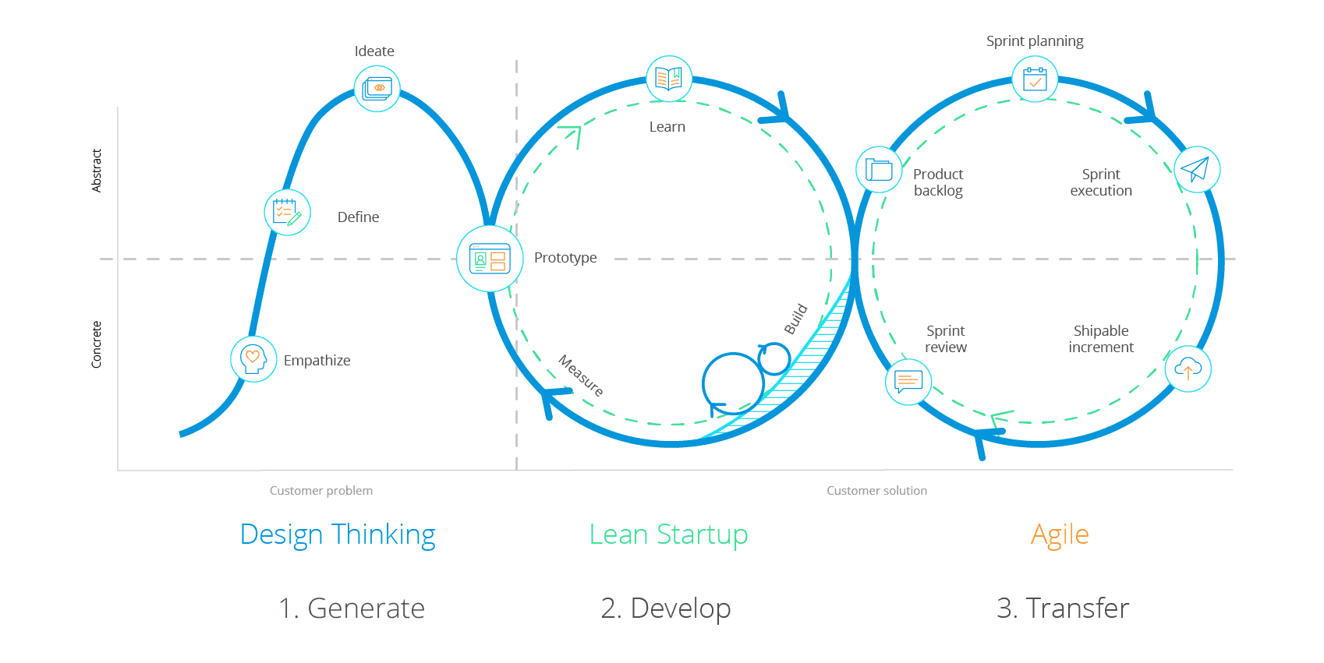

Figure 1 Design Thinking & Agile (<https://www.mendix.com/blog/design-thinking-vs-agile-combine-problem-finding-problem-solving-better-outcomes/>)

## Design Thinking Phase

In order to identify the problem and customer needs in the area a Design Thinking Approach was chosen. It consists the following phases:

* Empathize – Understand people, their behaviors, and motivations. Because people often don’t know, or can’t articulate, these things explicitly, understanding emerges through viewing users and their behaviors in context to identify patterns, ask questions, and challenge assumptions.
* Define – Create an actionable problem statement to define the right challenge to address, as well as the set of needs that are important to fulfill, based on the organization, its goals, and the perspective of end users.
* Ideate – Leverage techniques such as brainstorming, mind mapping, sketching, or creating paper prototypes to step back, go wide, and come up with more innovative or impactful solutions that weren’t originally envisioned.[1]

## Sprint Cycles

After the problem and the objectives in terms of Service Descriptions and Business Model are clear, the first sprint starts. Objectives identify functions which are required by the affected stakeholders to use the platform:

* Prototype – Bring ideas to life by showing, not telling; quickly create working prototypes to put something into users’ hands and begin to collect real-world feedback.
* Test – Learn from users’ experience, iterate, and repeat the process as needed until reaching a Minimum Viable Product (MVP).[2]
* Sprint Retroperspectives

# Roles & Stakeholders

Project-Team

* Isabelle Ribeiro: Product Owner
* Yannick Nann: Scrum Master
* Simon Wild: Team
* Peter Grüner: Team

Stakeholder

* Knut Hinkelmann
* MSc BIS Students
* Company Representatives

# Design Thinking Phase

## Empathize: Identifying the problem and the potential need

To identify what is needed on the market an environment- and impact factors analysis has been conducted within research and brainstorming session. The following figure shows the environment and the position of our business (Start-Up)

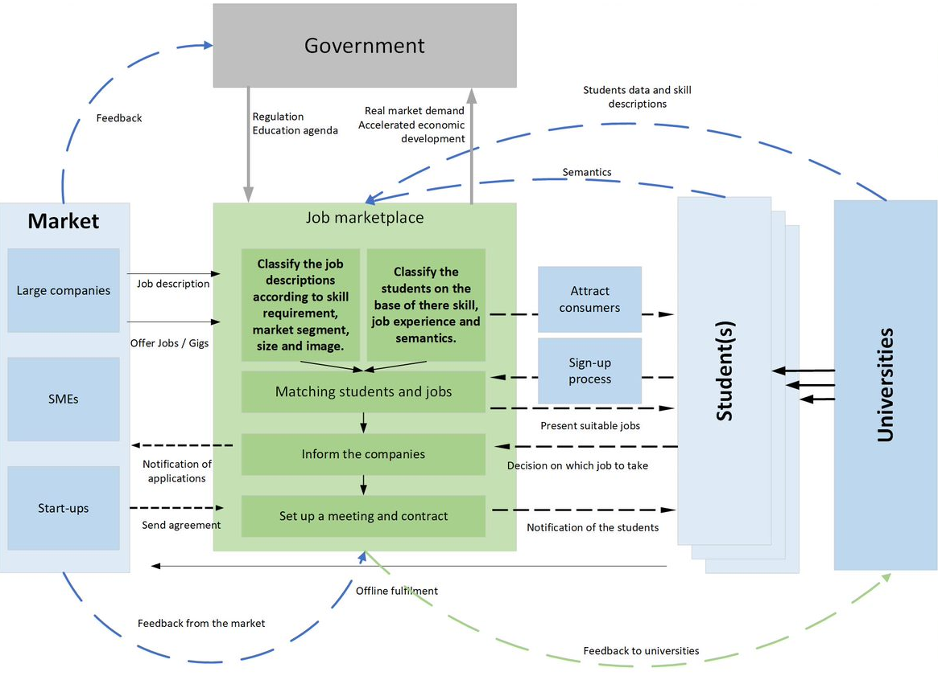

## Define Phase: Team Members define individually Service Descriptions

## Ideate Phase: Sharing Ideas and Prioritize

To define the actual service which the company will provide, the service descriptions from the design phase were discussed in the team. Each member had the possibility to vote and prioritize the different service descriptions. The evaluation was based on the following criteria:

### Service Descriptions Input

### Selected Service

### Definition of Company Name

# Backlog Creation (Initiative, Epics, User Stories)

Initiative: Platform for Sprout Scout

Gather High-Level Requirements and Objectives of FHNW (Stakeholder Knut Hinkelmann).

Gather High-Level Requirements and Objectives of Students (Stakeholder ABD Class)

Gather High-Level Requirements and Objectives of Companies (Stakeholder tbd)

Definition of Epics and User Stories based on HLRs

Create Backlog

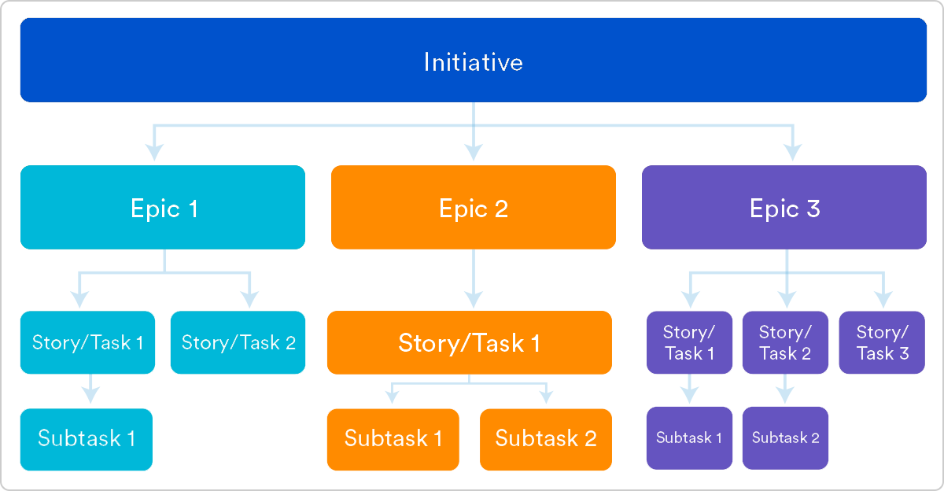

## Defined Backklog

Business Model

Evaluation of Prototyping and Mock-Up Tool

* Powerpoint
* AngularJS
* Justinmind Prototyper

Search Function for Students

Search Function for Companies

Profile Creation Function

Module Read Function (integration with eduram)

Job Description Upload Function

# First Sprint

## Sprint Planning (How does it work)

* Which Requirements have to be gathered first? What Kind of questions to be asked?
* Which functions of the Platform have to implemented first in the Prototype?
* Which technology is used for the platform? (machine learning, js, PHP, cloud, on prem)
* How should the platform function (usability /app/ layout) -> prototype
* Which functions (algorithms, search functions, matching functions) ->design/model

## Sprint

* Creating MockUps, Platform Function descriptions and Meta Models

## Sprint Retroperspective with Stakeholders

* How is the solution until now?
* Are there further requirements?
* How does the solution has to be adapted to achieve satisfaction?

1. <https://www.mendix.com/blog/design-thinking-vs-agile-combine-problem-finding-problem-solving-better-outcomes/>
2. <https://www.mendix.com/blog/design-thinking-vs-agile-combine-problem-finding-problem-solving-better-outcomes/>